HIGH COURT CLAIM: PT-2025-000853
HIGH COURT INJUNCTION IN FORCE
NOTICE OF HIGH COURT ORDER DATED 11 FEBRUARY 2026
A FULL COPY OF THE APPLICATION CAN BE FOUND VIA THE LINK BELOW
TO: PERSONS UNKNOWN WHO WITHOUT THE PERMISSION OF THE CLAIMANT ENTER ON OR REMAIN ON THE LAND REGISTERED AT HM LAND REGISTRY UNDER TITLE NUMBERS GM459851 AND GM459852 AS MARKED RED ON THE PLAN AT SCHEDULE 1 TO THE CLAIM FORM (“DEFENDANTS”).  FROM: ELECTRIC GLASS FIBER UK LTD (“CLAIMANT”)  CONCERNING: ALL LAND REGISTERED UNDER TITLE NUMBERS GM459851 AND GM459852 SITUATED AT HINDLEY GREEN, WIGAN SHOWN ON THE PLAN EDGED RED (“LAND”)  ON 11 FEBRUARY 2026 THE COURT GRANTED AN ORDER THAT PROHIBITS THE DEFENDANTS FROM COMMITTING THE FOLLOWING ACTS:  - ENTERING OR REMAINING ON THE LAND;  - ENTERING OR REMAINING IN OR ON ANY BUILDING ON THE LAND;  - DAMAGING ANY BUILDING, STRUCTURE, FIXTURE OR ITEM ON THE LAND;  - REMOVING OR ATTEMPTING TO REMOVE ANY ITEM FROM THE LAND.  THE COURT HAS ORDERED THAT SERVICE OF THE ORDER CAN BE PROVIDED TO THE DEFENDANTS BY THIS NOTICE. COPIES OF THE ORDER AND APPLICATION CAN BE FOUND: www.negeurope.co.uk  IF YOU THE DEFENDANTS DISOBEY THIS ORDER AND COMMIT ANY OF THE ABOVE ACTS YOU MAY BE HELD IN CONTEMPT OF COURT AND MAY BE IMPRISONED OR FINED OR HAVE YOUR ASSETS SEIZED. | 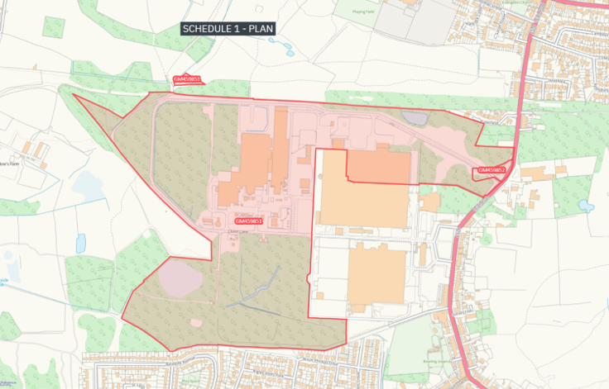  CLAIMANT’S SOLICITORS: HILL DICKINSON LLP, 1 ST MICHAEL’S, 36 JACKSON’S ROW, MANCHESTER, M2 5WD (e: HELEN.EVANS@HILLDICKINSON.COM).  COURT COMMUNICATIONS: ALL COMMUNICATIONS TO COURT ABOUT THIS ORDER MUST BE SENT TO THE COURT MANAGER, HIGH COURT OF JUSTICE (REF: PT-2025-000853) DETAILS FOUND AT: https://www.find-court-tribunal.service.gov.uk/courts/chancery-division

